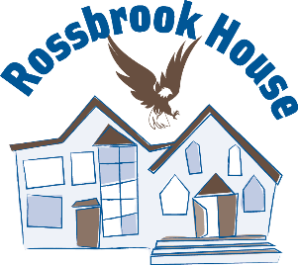
Rossbrook House official scholarship application.
Name:
Full mailing address:
Birthdate: Phone Number:
Email:

Please provide a phone number and email address. You will be contacted upon receipt of your application. You will be notified in September if you are receiving an award. Scholarships are awarded in person at a day ceremony the first Thursday of November. If you are unable to attend due to school or another commitment, other arrangements will be made.
Tell Us About Your Plans (Complete section A or B)

- First year/New program:
What is the name of your program?

Name of the school/facility:

What is your start date and end date (graduation date if applicable)?

Have you applied for admission? Yes / No (circle one)

Have you been accepted into the program? Yes / No (circle one)
Include a copy of your acceptance letter with this application.

B) If you are already studying in this program:
Name of the program& school:

When did you start?
When do you expect to graduate?

Section C: To be completed by all applicants
Is your program online or in-person?

Do you have travel costs associated with your program? If yes, explain:

Do you have internet or other technical costs associated with this program? Please provide
details here:
Section D: To be completed by all applicants
Name of High School or last school attended | Last year attended or graduation year
List any Post Secondary programs taken | List the years of attendance

Did you attend Wi Wabigooni or Eagles’ Circle or Rising Sun?
If so, please provide the years of attendance for any (all) schools.
Section E: To be completed by all applicants
Rossbrook House scholarships are intended to support the hopes and dreams of our
community.

Are you a former or current participant or staff?

Please provide the years you attended and/or your age when you were a participant.

Are you a parent of a current participant or related to one of the staff?

Please tell us in a few sentences about your relationship with Rossbrook House:
Attach another document/page if needed.

I understand that in order to receive any award made as a result of this application, I must maintain good standing in a vocational or academic program approved by Rossbrook House.

Signature: Date:

Please note: Only this application will be accepted and must include:
- Most recent school transcript(s) does not have to be official transcript. Copies or screenshot(is) are accepted.
- Program acceptance letter for new program or start date and confirmation of enrollment for a recurring program. (screenshots are accepted)

Email or drop off this application and accompanying documents to Sherry Rasmussen.
Any and all questions can be directed to:
Sherry Rasmussen 204-894-9491
srasmussen@rossbrookhouse.ca

